The Mediterranean region faces significant socio-environmental challenges, including climate stress, water scarcity, agricultural dependency, urbanization, and ecosystem degradation. In recent decades, agricultural activities have intensified [1]., exerting increasing pressure on natural resources, the economy, and society [2]. Given agriculture's critical role in the region’s economy, the combined impacts of climate change, deforestation, and soil erosion further exacerbate resource depletion. To ensure sustainability and resilience at both local and regional levels, an integrated resource management approach is urgently needed to drive meaningful territorial impact.
Table 1: Surenexus Pilots description
Policy Brief: From Fragmentation to Integration: Strengthening Public Policies through the WEFE Nexus

The Surenexus Project (N. 2142) aims to promote sustainable Nexus-Oriented solutions encompassing Water, Energy, Food and Ecosystem (WEFE). Through 4 Pilots in the Mediterranean region (Spain, Greece, Morocco, Israel) as shown in Figure 1, the project has implemented Nature-based (NbS) and Bioeconomy solutions (BES) governed by the WEFE Nexus thinking (Table 1). The Pilots have demonstrated how a combination of NbS and BES promote the sustainability of the regions, improving water consumption and quality, clean
energy production and independence, sustainable and efficient food production and ecosystems preservation [3], [4].
Across all pilots, comprehensive European, national, and regional policies provide the foundation for implementing WEFE solutions. The alignment with multiple directives, plans, and laws ensures that each solution not only addresses immediate environmental and resource management challenges but also contributes to broader sustainability goals. However, specific gaps remain, such as the need for decentralized
water treatment policies, better integration of agrivoltaics systems, and stronger frameworks for zero-waste production.
Pilots | WEFE Solutions | Purpose
Spain | Treatment wetlands with cork waste | Winery wastewater treatment
Greece | Solar desalination, wastewater treatment | Tropical fruit production, self-sufficiency
Morocco | Smart irrigation | Citrus cultivation
Israel | Mixed agrivoltaics systems | Vineyard optimization
Highlights
► Agriculture in the Mediterranean at a Breaking Point. Climate stress, water shortages, and soil decline are putting Mediterranean food systems at serious risk.
► Innovative Solutions on the Rise: Cutting-edge NbS and BES are already available, designed to promote holistic Nexus based approaches to revolutionize the agricultural landscape. What’s missing is scale and systemic uptake.
► Policies Are in Place—But Fragmented. Comprehensive policies and legal frameworks exist at Euro-Mediterranean, national, and regional levels—but they often operate in silos, limiting their effectiveness in real-world Nexus challenges.
► System Thinking Still Lacking:. Current regulations often fail to capture the complex interconnections between water, energy, food, and ecosystems—leaving critical gaps in cross-sector coordination and long-term resilience.
► Resource Interdependence Is the Missing Lever. Ensuring the long-term resilience of agriculture demands that national and regional systems actively embrace and manage resource interdependencies. Promoting Nexus-aware planning is no longer optional—it’s urgent.

Public policies aim to address social, economic and environmental problems through specific instruments and guidelines [5]. However, when problems are complex and trade-offs are observed, the challenge intensifies and policy fragmentation limits problem-solving.
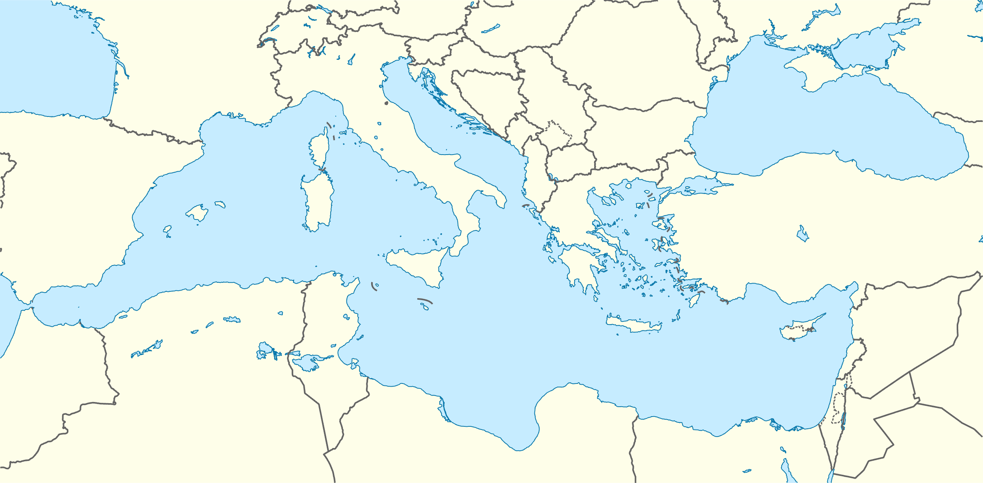

Applying the Nexus approach to identify interface points across sectoral policies reveals the fragmentation within current frameworks—and highlights a clear path forward. This path calls for rethinking governance processes to improve policy implementation through stronger collaboration among government, civil society, and private sector actors.
Figure 1: Surenexus Pilots location
When asking “What is missing in the national and local legislation to promote holistic agricultural policies?”, it becomes essential to first understand the current policy landscape and its impact on the management of water, energy, food, and ecosystems across the Euro-Mediterranean, national, and regional levels.
- Water
On an EU level, the Water Framework and the Wastewater Treatment Directive provide a framework for water quality through monitoring systems on a river basin scale [6, 7]. Water management is further promoted through the Programme of Measures, including integrated water resource management, habitat protection and water efficiency [6].
At the National level, both Spain and Greece have aligned with and implemented the EU’s policy frameworks, following a river-basin management approach and the water quality standards for water and wastewater treatment. Catalonia further established the Water Management Plan for regional policies, targeting local challenges [8]. Spain’s Royal Decree 1085/2024 updates and reinforces the water reuse framework established by RD 1620/2007, aiming to ensure higher quality and safety of reclaimed water, promote its reuse, and advance sustainable water management. The decree introduces tighter authorization rules, sets a 10-year permit validity, and requires water reuse risk management plans [9]. Morocco’s National Water Strategy and National Water Plan target the sustainable and efficient use of water and water management [10]. The National Drinking Water Supply and Irrigation Programme further promotes modern irrigation systems [11]. Israel’s main legislation is the Water Law (1959) regulates water allocation and ensures sustainable management [12]. Furthermore, the Policy on Water Tariffs in Agriculture introduces financial mechanisms to promote water efficiency [13].
- Energy
Energy production is mainly regulated on an EU level through the Green Deal and the Renewable Energy Directive, while the Common Agricultural Policy promotes renewable energy production for agricultural activities [14, 15, 16]. Furthermore, the Clean Energy for EU Islands Initiative boosts energy independence [17].
Nationally, the four countries promote practices for integration of renewable energy production in agricultural systems. Financial incentives for solar-powered systems are present in all countries. Furthermore, Israel and Spain promote particularly agrivoltaics for agriculture, through the National Action Plan on Climate Change and Catalonia's Guidelines for Agrivoltaics Installations respectively [18, 19]. Mentions about the energy communities that clearly address WEFE nexus improvements are explicitly mentioned in Spain (RD 244/2019; RD-Law 23/2020) and Greece (Law No. 4513/2018; Law No. 5037/2023).

- Food
Competitive and sustainable food production is the main objective of the policies in the four countries. EU’s Eco-Schemes, including precision farming, organic farming or agroforestry, promote sustainable food production [20].
The agricultural sector of Greece is regulated and enhanced through the National Strategy for Sustainable and Competitive Agriculture [21]. Spain promotes financially sustainable agriculture and rural development, as well as research and innovation in the field [22].
Morocco has set policies for climate-resilient farming. Morocco introduced a new agricultural policy called the "Génération Green 2020-2030" strategy [23]. launched in February 2020. This initiative builds upon the achievements of the previous "Plan Maroc Vert", aiming to further modernize and sustain the agricultural sector. The World Bank's "Transforming Agri-food Systems" Programme further supports Morocco's efforts by promoting climate-smart farming, no-tillage agriculture, and organic farming to enhance food production resilience against climate change [24].
- Ecosystems
The EU Taxonomy Regulation, through the conservation of natural habitats and the biodiversity, promotes both sustainable food systems and the protection and restoration of ecosystems [25].
Spain and Greece’s legislations recognize the need to protect and conserve the environment and the alignment of ministries and administrative bodies for the efficient resource management.
Morocco’s legislations and policies focus on ecosystem degradation and promote actions to protect, mitigate and combat such phenomenon. Israel’s policies give no evidence of ecosystem-targeted frameworks and guidelines.

To tackle the global challenges of water stress and urban transformation, policy frameworks must evolve to support efficient, competitive, and resilient agricultural systems. This requires a clear understanding of the critical interdependencies among water, energy, food, and ecosystems that shape the long-term viability and sustainability of both agriculture and the environment. Within this context, the SureNexus Project partners have identified key priority areas to consider:

- Policies and regulatory frameworks must explicitly reflect WEFE Nexus interconnections to ensure coordinated action and effective implementation at both national and regional levels.

While current policies have partially addressed resource interconnections—particularly between water and food, or energy and food systems, along with ecosystem considerations—they still fall short in fostering truly integrated approaches. For instance, technologies like smart irrigation systems, which optimize both water and energy use, have the potential to greatly improve agricultural efficiency. A promising example is the agri-voltaic systems implemented by SureNexus in Israel, which offer a replicable model for the broader Mediterranean region. To scale such innovations, targeted regulatory incentives—such as support for energy communities that harness solar power for smart irrigation—could serve as powerful enablers for widespread adoption.

- EU-promoted Eco-Schemes currently overlook the integration of water-energy interlinkages in their financial incentive structures.
Policy Recommendations in a Nutshell
► Mandate WEFE Nexus Integration: Embed the interconnections between water, energy, food, and ecosystems at the core of national and regional legislation to break sectoral silos and drive coordinated, sustainable policymaking.
► Redesign Eco-Schemes for Impact: Refocus financial incentives to reward agricultural practices that directly address water–energy linkages, unlocking the full potential of Eco-Schemes to support climate-smart and resource-efficient farming.
► Improve Administrative and Regulatory Coherence: Establish bold, cross-sector regulatory frameworks that synchronize water treatment, renewable energy, and agricultural policies—especially in high-stress regions like the Mediterranean—to maximize resource efficiency, accelerate sustainability, and build long-term resilience.

Eco-Schemes offer a valuable platform for promoting holistic and sustainable farming practices. However, the integration of water and energy interdependencies remains limited. To maximize their impact, direct payments should prioritize practices that address these critical linkages—such as the use of NbS such as treatment wetlands for water treatment. Incorporating innovative technologies and bio-based solutions, like cork granulates, can further enhance the effectiveness of Eco-Schemes, driving sustainability and resilience in the agricultural sector.

- Adopting system-based management and enhancing coordination among administrative departments and ministries are key to achieving more efficient and integrated resource management.

A systems-based approach to resource management is notably absent from the administrative and regulatory structures of all countries examined. Reorganizing institutional responsibilities to enable integrated, cross-sectoral decision-making—particularly in areas like agriculture—would enhance coordination and efficiency. For example, aligning water treatment regulations with agricultural policies and renewable energy incentives can significantly improve the sustainable reuse of treated wastewater for irrigation, especially in water-scarce regions like the Mediterranean.

References
[1] FAO, “THE STATE OF THE WORLD’S LAND AND WATER RESOURCES FOR FOOD AND AGRICULTURE 2021,” 2021. doi: 10.4060/cb9910en.
[2] A. ; Toreti et al., “Drought in the Mediterranean Region - January 2024,” Luxembourg, 2024. doi: 10.2760/384093.
[3] P. N. Carvalho et al., “Nature-based solutions addressing the water-energy-food nexus: Review of theoretical concepts and urban case studies,” J Clean Prod, vol. 338, no. June 2021, 2022, doi: 10.1016/j.jclepro.2022.130652.
[4] A. Tsatsou et al., “Participatory Selection of Nature-Based Solutions and Bioeconomy Solutions for WEFE Nexus Implementation: Applications on Tinos Island, Greece”, doi: 10.1007/s43615-025-00535-1.
[5] Michael. Howlett, Designing public policies : principles and instruments. Routledge, 2024. Accessed: Mar. 26, 2025. [Online]. Available: https://www.routledge.com/Designing-Public-Policies-Principles-and-Instruments/Howlett/p/book/9781032380865
[6] C. o. t. E. U. European Parliament, “Directive 2000/60/EC of the European Parliament and of the Council establishing a framework for the Community action in the field of water policy.,” Official Journal of the European Communities, 2000.
[7] E. Council, “Council Directive 91/271/EEC of 21 May 1991 concerning urban waste-water treatment.,” Official Journal of the European Communities, 1991.
[8] Catalan Water Agency, “Management Plan for the River Basin District of Catalonia and Programme of Measures. 2022-2027,” 2022. Accessed: Feb. 12, 2025. https://aca.gencat.cat/web/.content/30_Plans_i_programes/10_Pla_de_gestio/03-3r-cicle-de-planificacio-2022-2027/Document_sintesi_3er-cicle_ENG.pdf
[9] Government of Spain, Royal Decree 1085/2024, which establishes the legal regime for the reuse of treated wastewater. 2024.

[10] Ministére de l’Energie des Mines de l’Eau et de l’Environnement, “Loi n. 13-09 relative aux énergies renouvelable,” 2010.
[11] Government of Morocco, “National Drinking Water Supply and Irrigation Programme,” 2020. Accessed: Mar. 26, 2025.
[12] Water Law, 5719-1959. (1959). Sefer Ha-Chukkim, 13 August 1959, No. 228, p.169. Retrieved from UNEP Law and Environment Assistance Platform.
[13] Water Authority of Israel. (2023). Regulation and Tariffs of Water for Agriculture Services in Israel. Retrieved from WES-MED.
[14] European Commission. (2019). The European Green Deal. Retrieved from EUR-Lex.
[15] European Parliament and Council. (2018). Directive (EU) 2018/2001 on the promotion of the use of energy from renewable sources. Retrieved from EUR-Lex.
[16] European Commission. (2018). The Common Agricultural Policy Explained. Retrieved from Publications Office of the EU.
[17] European Commission. (2017). Clean Energy for EU Islands Initiative. Retrieved from Clean Energy for EU Islands.
[18] Ministry of Environmental Protection. (2021). National Action Plan on Climate Change 2022-2026. Retrieved from gov.il.
[19] Department of Climate Action, Food and Rural Agenda (DACC). (2024). Guidelines for Agrivoltaics Installations in Catalonia.
[20] European Parliament, REGULATION (EU) 2021/2115 OF THE EUROPEAN PARLIAMENT AND OF THE COUNCIL of 2 December 2021 establishing rules on support for strategic plans to be drawn up by Member States under the common agricultural policy (CAP Strategic Plans). 2021.
[21] Ministry of Rural Development and Food, “CAP STRATEGIC PLAN OF GREECE 2023-2027,” 2021.
[22] Ministry of Agriculture Fisheries and Food, “SPAIN’S COMMON AGRICULTURAL POLICY STRATEGIC PLAN (2023-2027).”
[23] Génération Green 2020-2030." Moroccan Ministry of Agriculture, Fisheries, Rural Development, Water and Forests, February 2020. Accessed April 1, 2025, www.agriculture.gov.ma/fr/ministere/generation-green-2020-2030.
[24] World Bank. (2024). Transforming Agri-Food Systems in Morocco Program. Retrieved from World Bank Documents.
[25] European Parliament and Council. (2020). Regulation (EU) 2020/852 on the establishment of a framework to facilitate sustainable investment, and amending Regulation (EU) 2019/2088. Retrieved from EUR-Lex.

