SURENEXUS Stakeholders Platform Guidelines

The PRIMA-funded project, SURENEXUS (Ensure Fair NEXUS Transition for Climate Change Adaptation and Sustainable Development), develops and tests solutions based on the Water-Energy-Food-Ecosystems (WEFE) Nexus. These solutions integrate ecosystem-based, scientific, and cutting-edge approaches to equitably and sustainably enhance climate resilience across diverse Mediterranean landscapes.
The project establishes four innovative demosites to demonstrate small-scale bioeconomy practices and nature-based solutions. These demosites evaluate the productivity and benefits of these practices for local communities. Additionally, SureNexus identifies key factors enabling the Nexus approach and assesses its potential across various Mediterranean scenarios. This work informs the design of Specific Socio-Ecological and Technical Systems (SETs) for Nexus implementation, which are shared with stakeholders through knowledge exchange and capacity-building activities to promote replication and scalability.
The consortium involves 15 partners from seven Mediterranean countries and prioritizes stakeholder engagement across multiple sectors to foster collaboration and innovation. To support this, the project creates a Stakeholders Platform (SHP), uniting public, private, and non-governmental organizations working across the four WEFE pillars. This platform facilitates cross-sectoral cooperation, knowledge sharing, and the dissemination of best practices throughout the Mediterranean.
The Stakeholders Platform (SHP) is designed to maximize the use and reuse of the project’s research results. It will define an action agenda, facilitate regular consultations for informed decision-making, and support the implementation of bold joint initiatives. Throughout the project lifecycle, the SHP will collect and validate data from diverse sources to guide research and achieve project objectives, ensuring updates and validation as needed.
The SHP plays a pivotal role in gathering data from its members and their local partners, validating analytical outcomes, and establishing pathways for sharing results and impacts across the region. Members of the SHP will benefit from capacity-building opportunities, knowledge dissemination, networking, and collaborative initiatives aimed at fostering the Nexus approach within their communities.

As a key stakeholder in implementing the WEFE Nexus approach in your country and the Mediterranean region, your organization is invited to join the SHP. Membership is voluntary and includes a range of actions that your organization can define in advance.
This document outlines the roles, contributions, responsibilities, and benefits of stakeholders, as well as mechanisms for transferring knowledge and lessons learned during the project.
At the end of this document, you will find a voluntary membership application form. If interested, you can specify your organization’s commitments as a member of the SHP and provide key information about your organization.

SHP and its role in the project SureNexus
Local networks are a cornerstone of the SureNexus project, driving its successful implementation and fostering knowledge exchange across the Mediterranean region. These networks enable the seeding, collection, development, and dissemination of technological, economic, and research innovations aligned with the NEXUS approach.
A core objective of the project is to communicate, disseminate, and leverage its results and outputs among stakeholders at all levels, maximizing regional and global impact through replication and adoption. Four networks operate in the demo site countries as part of the integrated Stakeholders Platform (SHP), connecting stakeholders across all Consortium member countries.
At the national level, intra-national networks address cultural, geographical, and institutional barriers to enhance stakeholder participation. These networks provide dynamic platforms for local partners to collaborate effectively, aligning on actionable solutions that scale to the regional level.
The SureNexus SHP operates on an interregional scale, bringing together stakeholders from multiple countries. It serves as a regional hub for aligning solutions, facilitating the exchange of experiences, disseminating WEFE Nexus knowledge, bridging knowledge gaps between Mediterranean countries, and fostering innovation to address climate change and other cross-border challenges. Its success depends on active participation, a collaborative environment that encourages knowledge sharing, and consistent communication among local and regional partners. By adhering to these principles, the networks will help advance the project’s goals and amplify its impact throughout the Mediterranean.
To this end, network members are expected to:
- Foster trust and active collaboration within the network.
- Ensure consistent and open information exchange across the network.
- Promote co-learning processes among the various local networks.

Involved stakeholders

An essential element for effective knowledge sharing is the identification of stakeholders who will be part of the network. In the context of the NEXUS approach, the nature, determinants, and interests of the organizations involved in collaborative networks are highly diverse.
To establish the SHP within the project, an initial stakeholder mapping was conducted, taking these factors into account. Organizations with local, national, and regional reach, working across the four NEXUS pillars, were identified, particularly those with experience in jointly implementing these pillars, whether under the NEXUS approach or not. However, actors with no prior experience were not excluded, as they are seen as important potential users of the project’s results.
These actors can be categorized as public, private, non-governmental, or social organizations. Given the broad scope of these categories and the varied nature of the organizations identified, it is important to note that they are not mutually exclusive; for example, some organizations may have a mixed nature, such as public-private partnerships. The specific types of organizations within each category are outlined below.

Public Organizations | Local Government
Public Organizations | National-Subnational Government
Reaserch Organizations | Reaserch centres & Universities
Private Organizations | Agri-food Companies
Private Organizations | Local Producers
Private Organizations | Water/Energy Utilities
Non-governmental Organizations | Customer Associations /NGOs

The project began in April 2022 and is scheduled to run until September 2025. SHP members are expected to participate throughout the project's lifecycle, with intensive collaboration during key phases such as data collection, validation, and dissemination. Members will be informed in advance of these periods, along with important dates for knowledge-sharing activities, including annual meetings, seminars, and conferences.
While participation in all activities is not mandatory, members can define their level of commitment in advance. However, active involvement throughout the project is strongly recommended to ensure effective collaboration and exchange within the platform.

Fostering Networking and Clustering

SureNexus activities are designed to offer significant benefits in addressing the diverse challenges faced by stakeholders, particularly in improving the understanding and enhancement of the Water-Energy-Food-Ecosystems (WEFE) Nexus. To achieve this goal, SureNexus will offer a range of products and services at no cost to SHP members. These offerings aim to support stakeholders in overcoming their challenges and making informed decisions within the NEXUS framework.

Below is a summary of the activities to which member organizations can contribute:

Design, creation, and testing of SETs: Members can provide strategic advice, consult with local partners, or participate in pilot tests and other activities to design and test small-scale bioeconomy and nature-based solutions, leading to the creation of Socio-Ecological and Technical Systems (SETs) for NEXUS implementation.

Information and data provision: Members play a key role in collecting and validating data throughout the project. They can provide relevant information through surveys, workshops, meetings, or documents, acting as a bridge between the project and local contexts.

Dissemination of results: Members help expand the reach of project results by sharing information through their networks and collecting feedback on user needs, interests, and collaboration opportunities.

Capacity building for local partners: Members can support local partners by building their capacity related to NEXUS knowledge and implementation.

Providing strategic advice and feedback: The platform encourages members to offer strategic input, collaborate on new initiatives, and contribute to co-creating funding proposals, research, and other projects within the NEXUS framework.

Identifying network stakeholders is crucial for the success of the knowledge exchange process. If stakeholders' expectations are not understood and managed properly, they may become disillusioned due to unmet hopes, personal ambitions, or fears. They may perceive the project as either under-ambitious or over-ambitious, leading to misalignment between the project's objectives and stakeholders' expectations.

Another challenge is the gap between the time and effort stakeholders are willing to invest and what the project requires, which can result in stakeholder fatigue.

Expectation management should start from the first meeting and continue throughout the project, with regular reality checks along the way. Understanding stakeholders' expectations is essential to integrating them effectively into the project. Therefore, it is important to clearly communicate expectations at the outset. The next step is to align stakeholders on a set of common goals related to the living lab and project objectives. While the network goals should be ambitious enough to motivate stakeholders, unrealistic expectations should be addressed and managed.

To avoid stakeholder fatigue, the network should be structured as a dynamic, engaging event that connects well with stakeholders. However, it’s important to find a balance between overloading stakeholders and engaging them frequently enough to keep the project moving forward.
Therefore, the level of collaboration and engagement with the platform should align with the interests and capacities of its members. Member organizations are encouraged to actively participate in all stages of the project, including dissemination activities and knowledge-sharing events. Their role is expected to go beyond simply receiving and sharing information; they should also contribute to the development of activities that help achieve the project’s objectives.

Below is a detailed description of the main activities focused for all member organizations. In addition to involvement, they can play a crucial role as contributors, leaders, or facilitators in these activities, depending on their expertise and capacity. Their active engagement will be vital to achieving the project’s objectives and maximizing its impact.

Table 1. SureNexus Activities for SHP Members
Main SureNexus Activity | Specific Acivity
Continuous Training and Capacity Building I : General Courses | WEFE Nexus (Approach, Governance, Metrics)
 | NbS & Ecosystems health and services
 | Circular “carbon” Bioeconomy
Continuous Training and Capacity Building II : Specialized Courses | AI Modelling & Scenario analysis for WEFE Nexus
 | NBS & Ancestral Hydrotechnologies
 | Climate change adaptation & WEFE nexus
 | Nexus Enabling Factors, Nexus Drivers of Change & Sustainability Indicators
On-demand Consultancy | Bioeconomy Practices
On-demand Consultancy | Digital agriculture & Agrivoltaics
On-demand Consultancy | Technology selection for water/wastewater treatment using NBS
On-demand Consultancy | Concerns in the Agricultural Sector (pollution, irrigation, …)
On-demand Consultancy | Resource efficiency (energy and water)
On-demand Consultancy | Climate change scenarios
Access to Technical Summaries and Newletters & Reports | Technical Summaries (reports available for main documents in 6 languages: EN, SP, IT, FR, GR, AR).
Access to Technical Summaries and Newletters & Reports | Newsletters,
Access to Technical Summaries and Newletters & Reports | Policy briefs
Access to Technical Summaries and Newletters & Reports | Award recognizing best initiatives on WEFE Nexus
Networking Opportunities & Join Actions | Stay Updated: Conferences / Workshops/ webinars/ Online Forums & Discussion Groups
Networking Opportunities & Join Actions | Exchange of knowledge and experience about WEFE-NEXUS approach
Networking Opportunities & Join Actions | Access to solutions from similar sector/Climate context

Benefits for SHP members

The following products will be made available free of charge to SHP members. These products will serve as valuable resources for SHP members to enhance their knowledge, support NEXUS implementation, and foster collaboration across sectors:

SureNexus Outcomes | Outcome Access for SHP members
Continuous Training and Capacity Building (General & Specialized courses) | Access to workshops / Confererences (discounted fees)
 | Access to Formation Materials
 | Recognized certification
On-demand Consultancy | 4 free consultations per organization (Annually)
On-demand Consultancy | 1 Climate Change scenario per location (Annually)
Access to Technical Summaries and Newletters & Reports | Access to Technical Summaries (reports available for main documents in 6 languages: EN, SP, IT, FR, GR, AR).
Access to Technical Summaries and Newletters & Reports | 1 report from each DS (4 sectorial reports)
Access to Technical Summaries and Newletters & Reports | 1 technical report on Plastics in Agriculture (CTPC)
Access to Technical Summaries and Newletters & Reports | 1 technical report on NbS for Agriculture
Access to Technical Summaries and Newletters & Reports | 1 technical report on Bioeconomy solutions for Agriculture
Access to Technical Summaries and Newletters & Reports | Free access for registered members to: Newsletters, Reports, Summaries, Guidelines, White Reports, …
Networking Opportunities & Join Actions | Access for Partners to the “Solutions to Similar Problems” Database (SiProS)
Networking Opportunities & Join Actions | Direct easy access to WEFE Nexus Community of Practices
Networking Opportunities & Join Actions | Access to and Use of the SHP Members Database

Outreach Plan

Effective communication between the project and SHP members is crucial. Equally important is ensuring that SHP members can convey the project's activities and scope to their local partners and gather feedback through their networks. To achieve this, various communication channels will be established.

The platform will be coordinated through an online management system, serving as an exclusive virtual space for consortium and platform members to access and organize relevant information. Additionally, regular communication via email will be maintained with each SHP member. To ensure smooth communication, members will designate a focal point responsible for channeling information, concerns, and knowledge within their organization and to local partners, as well as coordinating with other platform members.

The project’s website and social media pages will also serve as communication channels to share research results, updates, activities, and public information. SHP members are expected to share this information through their own communication channels to reach a wider audience, especially local stakeholders outside the project’s direct scope.

The project will also create additional communication and networking spaces, including online and face-to-face seminars, workshops, newsletters, and forums, to foster collaboration and facilitate the dissemination of results among platform members.

Internal Schedule for SHP Launch

The outlined steps below are essential for accelerating the formation of the SHP. Each partner plays a pivotal role in driving the adoption and successful implementation of the SHP framework, ensuring that all objectives are met effectively and collaboratively. Their active participation and commitment are key to building a strong and sustainable foundation for the SHP.

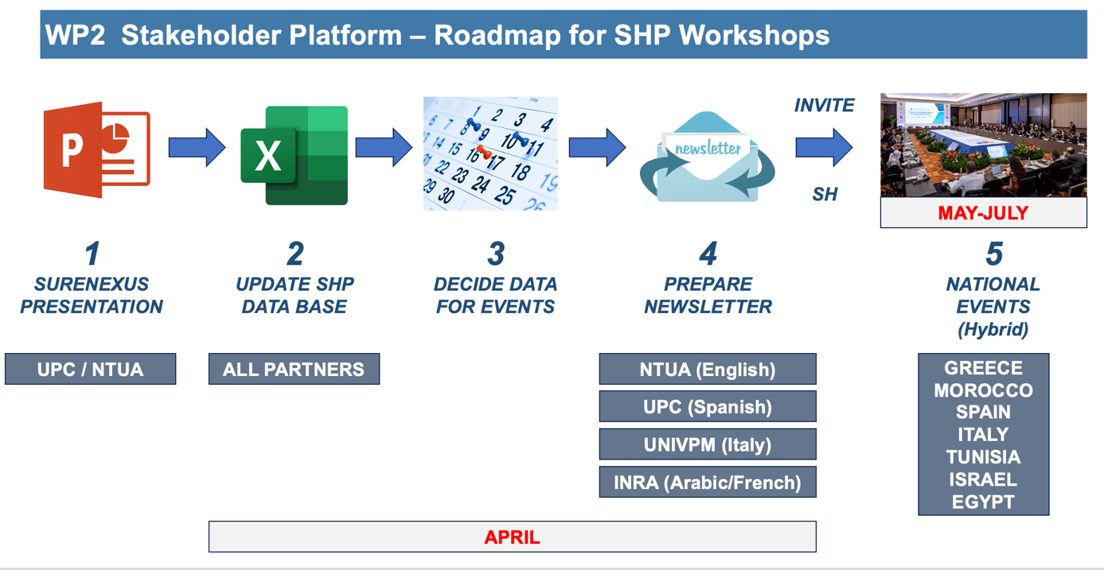

Voluntary Application for Stakeholder Platform Membership

Google form for SHP candidates. A Google Form was created to share with interested stakeholders, allowing them to provide input, express their interests, and specify their preferences for participation. This form aims to streamline communication, gather valuable feedback, and ensure the platform aligns with stakeholders' needs and expectations.

The link for google form is: https://forms.gle/n3LRucQ14mEUADZG8

Letter of Adhesion. A letter of adhesion has also been drafted to share with all interested organizations. This document formalizes their commitment to the initiative and serves as an official means to solidify partnerships and ensure alignment with the project's goals and values.

Letter of Adhesion to the SureNexus Stakeholder Platfom



City, Date

Name of representative
Name of organization & Role
Address
Country

Subject : Voluntary Membership Application

With this letter, Name of organization certifies that it supports the project SURENEXUS submitted by the consortium coordinated by Universitat Politècnica de Catalunya – UPC in response to the PRIMA-NEXUS 2021 call.

Name of organization is willing to contribute as member of the stakeholder platform setup by the SURENEXUS project. In particular, Name of organization agrees:

Please keep the statements based on yout level of commitment
- Participating in the design of socio-ecological and technical systems (SETs).
- Participate in the creation of SETs.
- Testing the SETs developed within the project.
- Supporting the dissemination of project results and content.
- Organising capacity building activities for local partners.
- Provision of information and data for the project.
- Providing strategic advice and feedback on project activities.

Our contact person for technical correspondence will be Name of the focal point , email: Email address, at this same address.

Name of representative and signature
Role in the organization

